Sauk Valley Community College
November 27, 2017

Agenda Item 3.1.1

Topic: College Recognition

Strategic Vision: Sauk Valley Community College will be a leader in student achievement while expanding access to higher education across the Sauk Valley region.

Presented By: Dr. David Hellmich, Dr. Steve Nunez, and Dr. Jon Mandrell

Presentation:
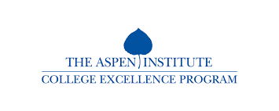
The College has received recognition from the following regarding its status as a leader in student achievement.

Sauk Valley Community College has been selected as one of only 150 nationally to be eligible for the fifth biennial $1 million Aspen Prize for Community College Excellence, the nation’s signature recognition of high achievement and performance in America’s community colleges.
The Aspen Prize, awarded every two years, has brought a new level of public attention to community colleges, defined comprehensive measures of excellence in outcomes for community college students (see below), and uncovered and disseminated practices that help exceptional colleges ensure great outcomes for their students.

 | Community College Averages
 | 52.7 | 39.6 | 37.4 | 2.1 | 34.5 | 22.7
Institution Name | Institutional Values
 | Performance |  |  | Change Over Time | Equity: Minority Rates
 | First-Year Retention Rate | Three-Year Graduation Rate | Credentials Awarded per 100 FTE Students | Performance variables - year-to-year increase or decline over 5 years | Three-Year Graduation Rate | Credentials Awarded per 100 FTE Students
Sauk Valley Community College | 61.5 | 57.5 | 37.3 | 7.0 | 49.2 | 20.1

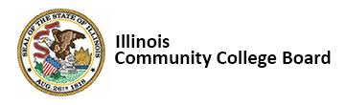
Performance-based funding was legislated by the Illinois General Assembly in June, 2012 with Public Act 97-320, which requires public higher education institutions to have a performance funding component in their budget annually. Performance based funding is not about money, but about performance. For community colleges, performance is defined not only by graduation rates, but also by entered employment, certificate attainment, persistence, and success towards college level coursework.

The following three statewide allocations have been made:

- FY 2013 – $360,000
  - Sauk’s allocation of $5,809 was 22nd largest out of 39 colleges.

- FY 2014 – $360,000
  - Sauk’s allocation of $18,814 was 5th largest out of 39 colleges.

- FY 2017 – $351,900
  - Sauk’s allocation of $16,390 was 4th largest out of 39 colleges.

SVCC’s Performance Based Funding Allocations by Measure | FY 2013 | FY 2014 | FY 2017
Degree & Certificate Completion | $2,130 | $8,516 | $2,015
Degree & Certificate Completion of At Risk Students | $3,202 | $1,364 | $780
Transfer to a 4-year Institution |  | $2,402 | $60
Developmental Advancement |  | $5,946 | $560
Momentum Points |  | $474 | $7,115
Transfer to a Community College | $477 | $112 | $5,860
Total | $5,809 | $18,814 | $16,390

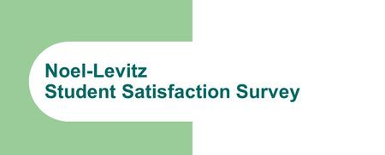
The Student Satisfaction Inventory (SSI) gives the College a powerful tool to improve the quality of student life and learning. It measures student satisfaction and priorities, showing how satisfied students are as well as what issues are important to them.
Sauk’s results from the 2017 SSI consistently scored in the 95th percentile of colleges nationally. For example, when asked if they are able to experience intellectual growth at SVCC, Sauk’s students rate the college 6.28 compared to 5.92 nationally, a 0.36 difference that is statistically significant at the .001 level. This rating reflects the commitment of Sauk’s faculty and staff to the academic success of our students.

Strengths
31. The campus is safe and secure for all students.
70. I am able to experience intellectual growth here.
58. Nearly all of the faculty are knowledgeable in their fields.
6. My academic advisor is approachable.
14. Library resources and services are adequate.
Higher Satisfaction vs. National Community Colleges
31. The campus is safe and secure for all students.
70. I am able to experience intellectual growth here.
58. Nearly all of the faculty are knowledgeable in their fields.
6. My academic advisor is approachable.
14. Library resources and services are adequate.
Higher Importance vs. National Community Colleges
31. The campus is safe and secure for all students.
70. I am able to experience intellectual growth here.
58. Nearly all of the faculty are knowledgeable in their fields.
6. My academic advisor is approachable.
14. Library resources and services are adequate.
Challenges
11. Security staff respond quickly in emergencies.
15. I am able to register for classes I need with few conflicts.
52. This school does whatever it can to help me reach my educational goals.
7. Adequate financial aid is available for most students.
18. The quality of instruction I receive in most of my classes is excellent.
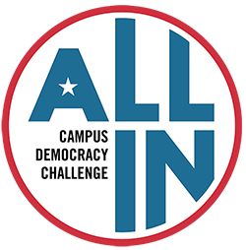

The ALL IN Campus Democracy Challenge believes that more young people need to participate in the electoral process. By recognizing colleges and universities for their commitment to increasing student voting rates, this national awards program encourages institutions to help students form the habits of active and informed citizenship. Hundreds of colleges and universities joined the Challenge and committed to making democratic participation a core value on their campuses. Together, they are cultivating generations of engaged citizens who are essential to a healthy democracy.
Sauk students, staff, and faculty leaders as well as campus organizations (most notably the Social Justice Club and the Student Government Association) worked together before the November 2016 election to increase the number of Sauk students who are democratically engaged and to make democratic engagement a normal part of college life at SVCC.

Sauk Valley Community College is the winner of two of the ALL IN Challenge's Best in Class Awards:

- Highest voting rate (51.6%) in the 2016 election among participating small, two-year, public institutions; and

Most improved voting rate (5.8%) from the 2012 and the 2016 elections among participating small, two-year, public institutions.

Sauk Valley Community College
November 27, 2017

Agenda Item 3.1.2

Topic: Marketing Videos

Strategic Direction: Goal 1, Objective 2 – Be responsive to community needs by offering new and appropriate academic programs and classes

Presented By: Dr. David Hellmich and Dr. Steve Nunez

Presentation:
To support the expansion of both the business/customized training and community education departments and strategic objectives 1.4 and 1.5, the Marketing Department has been working with Comcast to develop two thirty-second commercials to be played on television and social media outlets. These will be the first commercials for their respective departments.

Sauk Valley Community College
November 27, 2017

Agenda Item 3.1.3

Topic: New Fees Model

Strategic Direction: Goal 1, Objective 3 – Be operationally efficient in order to maintain a low cost of attendance for students

Presented By: Dr. David Hellmich, Dr. Jon Mandrell, and Melissa Dye

Presentation:
A task force was formed last academic year to take a comprehensive look at the College’s tuition and fees model. Led by Janet Matheney and consisting of Melissa Dye, Jon Mandrell, Pam Medema and Jennifer Schultz, this group looked at state and national community college tuition and fees models and sought feedback from faculty and staff. The College’s emerging new fees model will be reflected in fees to be considered by the Board at the upcoming February meeting.

Sauk Valley Community College
November 27, 2017

Agenda Item 3.1.4

Topic: Clery Safety and Security Report

Ethical Values: Sauk Valley Community College respects the worth and dignity of all people; stands for integrity and fairness; and encourages responsibility, accountability, and persistence in a caring, supportive environment.

Presented By: Dr. David Hellmich and Frank Murphy

Presentation:
Sauk Valley Community College Annual Security Report and Fire Safety Report is published in compliance with the Jeanne Clery Disclosure of Campus Security Policy and Campus Crime Statistics Act (“Clery Act”), the State of Illinois Campus Security Enhancement Act, and Violence Against Women Act (VAWA).
This report addresses Sauk’s policies, procedures, and programs concerning safety and security. Statistics for three prior years are included for certain types of crimes reported to have occurred on campus and on public property immediately adjacent to the campus. It is available on the College’s website at the following address: https://www.svcc.edu/departments/irp/reporting/campus-security-report.pdf .

